WITHOUT ERROR
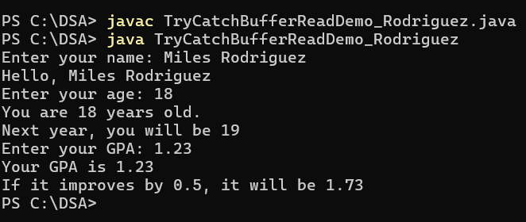

WITH ERROR
